MASTER INTERVIEW REVISION GUIDE & TECHNICAL CHEAT SHEET
Position: Network Engineer | Company: ESCA Trading & Engineering Services SNC | Candidate: Muhammad Ainul Fitiri bin Muhammad Jasni

1. Candidate Executive Summary & Natural Introduction

1.1 Authentic 'Tell Me About Yourself' Script
Deliver this naturally and conversationally. Do not pretend to be solely a traditional router/switch technician; instead, showcase your full 7+ year progression from physical infrastructure to enterprise operations, IAM/PKI, SOC incident engineering, and multi-campus network perimeter management:
📌 Elevator Pitch Script (Verbatim Talking Points)
"Thank you for having me today. My name is Ainul, and I have over 7 years of hands-on experience across IT infrastructure, enterprise networking, and cybersecurity operations here in Brunei and supporting international environments.
My career began right at the physical layer: back in 2018 and 2019, I was doing hands-on fiber optic cabling, POS hardware setups, and data center cabling upgrades with Sistem Integra and Falah-Tek. That gave me an appreciation for the foundational physical and data link layers of networking.
I then spent several years with DXC Technology supporting major enterprise environments including Brunei Shell Petroleum (BSP). In those roles, I handled enterprise customer support, disaster recovery operations, and later advanced into Identity & Access Management (IAM) and SOC analysis. I specialized in Kerberos, PKI certificate lifecycles, SAML/SSO integrations, and security log analysis in Splunk.
Over the next few years, I worked with Eventus Security assigned to ITPSS and EVYD Technology as a Cybersecurity Operations Engineer, where I deployed and tuned Microsoft Sentinel SIEM, firewalls, WAF, and Trend Micro XDR, and served as the ISMS Management Representative leading ISO 27001 implementation. I also consulted remotely for Halian International supporting Propertyfinder UAE, automating cloud infrastructure and VPC network security in AWS.
Currently, I am the Senior IT Technician and primary Cybersecurity Engineer at International School Brunei (ISB). In this role, I manage network security operations, controls, and incident response for over 1,100 students and 350 staff across multiple campuses. A major part of my daily responsibility is operating our Barracuda next-generation firewalls, Web Security Gateways, secure VPN tunnels, and driving our campus wireless perimeter security—specifically deploying certificate-based 802.1X EAP-TLS Wi-Fi authentication using Microsoft Intune and enterprise PKI.
What brings me to ESCA is your engineering reputation in Brunei. As a Bruneian local, I am looking to bring my deep background in network perimeter defense, firewall administration, PKI-driven network access control, and incident troubleshooting into your Network Engineering team to design, deploy, and maintain highly secure and resilient enterprise network infrastructure."

1.2 Strategic Framing for Critical Interview Questions
- Q1: Why apply for a Network Engineer role when your title is Cybersecurity?: "In modern enterprise engineering, networking and security can no longer be siloed. A network that isn't secure is a liability, and security tools can't function effectively without deep knowledge of TCP/IP, routing, switching, packet flow, and VLAN segmentation. My cybersecurity and incident engineering background makes me a better Network Engineer because I don't just configure routes and ports; I design resilient networks with root-cause troubleshooting, high availability, and zero-trust perimeter defense in mind."
- Q2: The poster asks for a Bachelor's Degree and CCNA; you hold a Level 5 Diploma and ITIL v4. How does that compare?: "I graduated with a Level 5 Diploma in Information Systems from Politeknik Brunei, and since then I have built 7 continuous years of hands-on, production experience across enterprise data centers, DXC Technology, ITPSS, EVYD, and International School Brunei. Certifications like CCNA validate theoretical fundamentals, but my day-to-day work involves directly configuring production firewalls, IPsec VPN tunnels, 802.1Q trunking, dynamic VLANs, RADIUS 802.1X authentication, and packet analysis with Wireshark. Furthermore, I am eager and prepared to sit for vendor certifications like CCNA as part of my professional milestones at ESCA."
- Q3: What advantage do you bring as a Bruneian local?: "Being a Bruneian local means I am physically on the ground, immediately available for on-site emergencies, maintenance windows, and physical data center dispatch. I understand the local enterprise landscape, telecommunications providers (such as UNN), regulatory compliance frameworks like Brunei's PDPO and ISO 27001, and can communicate seamlessly with cross-functional Bruneian teams, clients, and technical stakeholders."

2. ESCA Job Poster Alignment Matrix
Every requirement and responsibility from the ESCA Trading & Engineering Services SNC job poster mapped directly to your proven track record:
ESCA Job Requirement / Responsibility | Ainul's Direct CV Experience & Proof Points | How to Articulate in the Interview
Minimum 5 years experience managing network infrastructure | 7+ years total experience across enterprise environments: Falah-Tek (2019), DXC (2019-2021 & 2023-2025), ITPSS (2021-2022), EVYD (2022-2023), Halian (2025), ISB (2026-Present). | Highlight your journey from physical cabling to enterprise operations, IAM/PKI, and multi-campus perimeter management.
Deep understanding of networking concepts (TCP/IP, routing, security principles) | Daily administration of IP subnets, VLANs, inter-VLAN routing, NAT/PAT, DNS/DHCP, and Zero Trust access controls across 1,100+ students and 350+ staff at ISB. | Emphasize your practical command of TCP/IP state tracking, subnet design, 802.1Q trunking, and least-privilege Zero Trust segmentation.
Proficiency in firewall config, IDS/IPS, and VPN technologies | Primary administrator of Barracuda Next-Generation Firewalls, Web Security Gateways, and secure IPsec/SSL VPN tunnels at ISB; WAF and cloud firewalls at EVYD and Propertyfinder. | Discuss stateful rule configuration, AppID signatures, SSL deep packet inspection, and terminating site-to-site IPsec & remote access VPNs.
Network monitoring and analysis tools | Practical packet inspection with Wireshark and CLI tools (tcpdump); enterprise log correlation using Splunk, Elasticsearch SIEM, and Microsoft Sentinel. | Explain how you capture packets, inspect TCP flags/retransmissions, and correlate logs in SIEM during high-impact outages.
Install, configure, and maintain hardware (routers, switches, firewalls, VPNs) | Campus network hardware management at ISB; earlier data center and fiber optic infrastructure at Sistem Integra and Falah-Tek. | Highlight physical and logical expertise: fiber termination, rack installs, switch provisioning, trunking, and scheduled firmware patching.
Vulnerability assessments and incident investigation | Hands-on vulnerability scanning using Nessus at DXC and EVYD; incident investigation and containment across endpoint, network, and cloud at ISB and ITPSS. | Walk through conducting Nessus scans, prioritizing remediation, and executing switch-port isolation / dynamic VLAN quarantine.
Security policies, compliance, and documentation | ISO 27001 ISMS Management Representative at EVYD; developing cybersecurity policies, tabletop exercises, and PDPO compliance procedures at ISB. | Discuss leading ISO 27001 certification audits and writing network SOPs, DR runbooks, and Brunei PDPO policies.

3. Core Deep Dive 1: Barracuda Next-Gen Firewalls (NGFW) & Web Security Gateways (WSG)

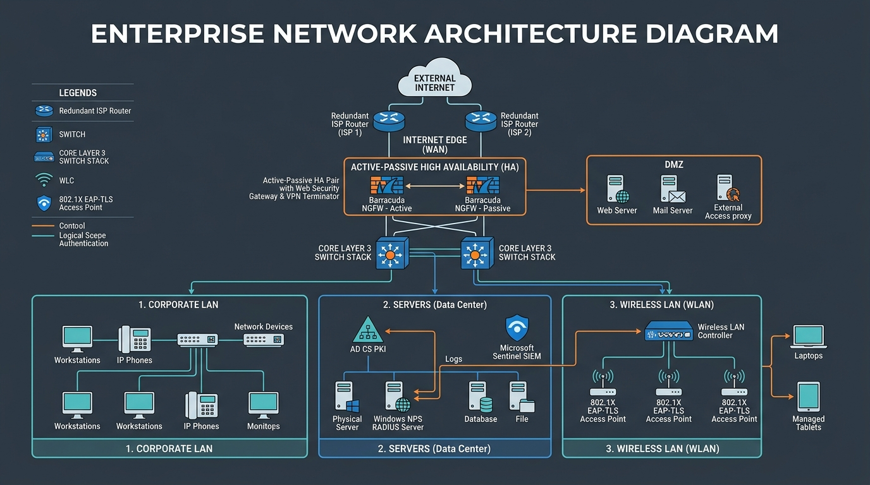
Figure 1: Enterprise Network Perimeter Architecture & High Availability Topology

3.1 Barracuda NGFW Packet Inspection Pipeline
When a packet arrives at an interface on a Barracuda CloudGen / Next-Gen Firewall, it traverses an 8-stage inspection engine:
- 1. Ingress & uRPF Check: Validates Reverse Path Forwarding to verify that the source IP matches the routing table and prevents IP spoofing.
- 2. State Table Lookup: Checks existing connection tracking table. Established sessions bypass rule re-evaluation.
- 3. DNAT (Destination NAT): Translates public destination IP to internal private IP before security rule evaluation.
- 4. Firewall Rule Evaluation: Evaluated top-to-bottom, first-match based on Source, Destination, Service, Time Schedule, and Identity.
- 5. Application Control (AppID): DPI engine inspects payloads to identify applications regardless of port (e.g. detects Tor or BitTorrent running over port 443).
- 6. IPS & Threat Protection: Scans against Snort/Barracuda vulnerability signatures, shellcode exploits, and C2 IP lists.
- 7. Source NAT (SNAT): Translates internal RFC 1918 private IPs to public WAN IPs for outbound egress.
- 8. Egress Routing: Transmits the packet out the designated egress interface.

3.2 SSL/TLS Deep Packet Inspection (SSL Interception)
How to explain SSL inspection in the interview without causing browser warnings or breaking critical applications:
- Root CA Installation: Barracuda's Subordinate/Enterprise CA certificate is distributed to all Windows and iPad endpoints via Microsoft Intune / GPO into the Trusted Root Certification Authorities store.
- Man-in-the-Middle Termination: When an endpoint visits an HTTPS site, Barracuda intercepts the TLS Client Hello, connects to the destination server independently, inspects the external certificate, and issues an on-the-fly certificate signed by the Barracuda Root CA back to the client.
- Payload Decryption & Re-encryption: The firewall decrypts the traffic, applies antivirus, IPS signatures, and URL filtering, then re-encrypts the stream.
- Mandatory Bypass Lists: Finance/Banking (Baiduri, BIBD), Healthcare, and apps with Certificate Pinning (Apple Updates, Microsoft 365 licensing) MUST be bypassed to avoid breaking connections and violating privacy laws.

3.3 Web Security Gateway (WSG) & Bandwidth Shaping
- Category Filtering: Blocking Malicious/Phishing, Gambling, P2P, and Anonymizer/Proxy categories. Enforcing time-based rules for social media.
- SafeSearch & YouTube Restrictions: Injecting 'YouTube-Restrict: Strict' HTTP headers into outbound requests and rewriting DNS CNAMEs for Google search.
- QoS Traffic Shaping: Guaranteed bandwidth allocated to administrative VLANs and VoIP (SIP 5060, RTP); throttling student/guest streaming.

3.4 Barracuda Live Troubleshooting Playbook
Step-by-step diagnostic workflow during an outage:
1. Open Barracuda Live Log / Firewall Activity.
2. Filter: Source IP = <client_IP> AND Destination IP = <target_IP>.
3. Interpret Action Column:
- PASS: Firewall allows traffic. Problem is upstream (ISP/routing) or server-side.
- DROP - NO RULE MATCH: Hit default cleanup rule; write explicit forwarding rule.
- DROP - APP CONTROL: Application signature blocked (e.g. proxy bypass tool).
- DROP - IPS: Attack signature triggered; inspect false positive threshold.
4. CLI Diagnostics (SSH into Barracuda console -> 'phion' subsystem):
# phion sessions
# phion connection list | grep <client_IP>
# tcpdump -i eth0 host <client_IP> and port 443 -nn
# ip route show

4. Core Deep Dive 2: Secure VPN Tunnels (Site-to-Site & Client-to-Site)

4.1 Site-to-Site IPsec VPN Mechanics
- IKE Phase 1 (ISAKMP SA): Authenticates tunnel peers and establishes a secure management tunnel. Parameters that MUST match: Encryption (AES-256-GCM), Hash (SHA-256), Diffie-Hellman Group (Group 14 2048-bit or Group 19 ECC), Authentication (PSK or X.509 cert), and Lifetime (28800s). Uses UDP port 500 or UDP port 4500 (NAT-Traversal).
- IKE Phase 2 (IPsec SA / Quick Mode): Negotiates user data encryption parameters using ESP (Encapsulating Security Payload - IP Protocol 50). Perfect Forward Secrecy (PFS) forces a new DH exchange for every rekey. Proxy IDs (Local Subnet <-> Remote Subnet) must match exactly.
- Route-Based (VTI) vs Policy-Based: Route-Based uses Virtual Tunnel Interfaces (vti0) and allows running dynamic routing protocols like OSPF and BGP across the tunnel, whereas policy-based relies strictly on static ACLs.

4.2 VPN Troubleshooting Diagnostic Table
Symptom / Error Code | Likely Root Cause | Exact Resolution Action
Phase 1 Down: NO_PROPOSAL_CHOSEN | Mismatched encryption cipher, hash algorithm, or DH group. | Compare Phase 1 proposals side-by-side (e.g. verify AES-256 vs AES-128, SHA-256 vs SHA-1).
Phase 1 Down: AUTHENTICATION_FAILED | Incorrect Pre-Shared Key (PSK) or peer IP mismatch. | Re-enter PSK on both firewalls to eliminate whitespace/typo errors. Verify peer IP.
Phase 1 Down: PEER_NOT_RESPONDING | Traffic blocked upstream by ISP or intermediate firewall. | Ensure UDP 500 (IKE) and UDP 4500 (NAT-T) are allowed through intermediate firewalls.
Phase 1 UP, Phase 2 Down: PROPOSAL_MISMATCH | Mismatched ESP encryption or PFS DH group setting. | Align Phase 2 crypto proposals and ensure PFS is enabled on both sides.
Phase 1 UP, Phase 2 Down: INVALID_TRAFFIC_SELECTOR | Proxy ID / encryption domain subnet mismatch. | Ensure Local Subnet on Site A equals Remote Subnet on Site B exactly (e.g. /24 vs /16).
Tunnel UP, but no traffic flows | Missing route, firewall policy blocking zone, or MTU black hole. | 1. Check routing table.  2. Verify firewall rule allowing VPN-to-LAN.  3. Configure TCP MSS Clamping to 1360-1400.

4.3 Client-to-Site Remote Access VPN
- Authentication: Multi-Factor Authentication (MFA) integrated with Microsoft Entra ID via SAML 2.0 or RADIUS.
- Split-Tunnel vs Full-Tunnel: Split-tunneling sends only corporate IP subnets (10.0.0.0/8) over the VPN, conserving corporate bandwidth; Full-tunneling forces 100% of traffic through the firewall for maximum security posture.
- Client Posture Checking: Barracuda Network Access Client validates endpoint OS patch level, domain membership, and antivirus state before granting tunnel access.

5. Core Deep Dive 3: 802.1X Certificate-Based EAP-TLS Wi-Fi Authentication

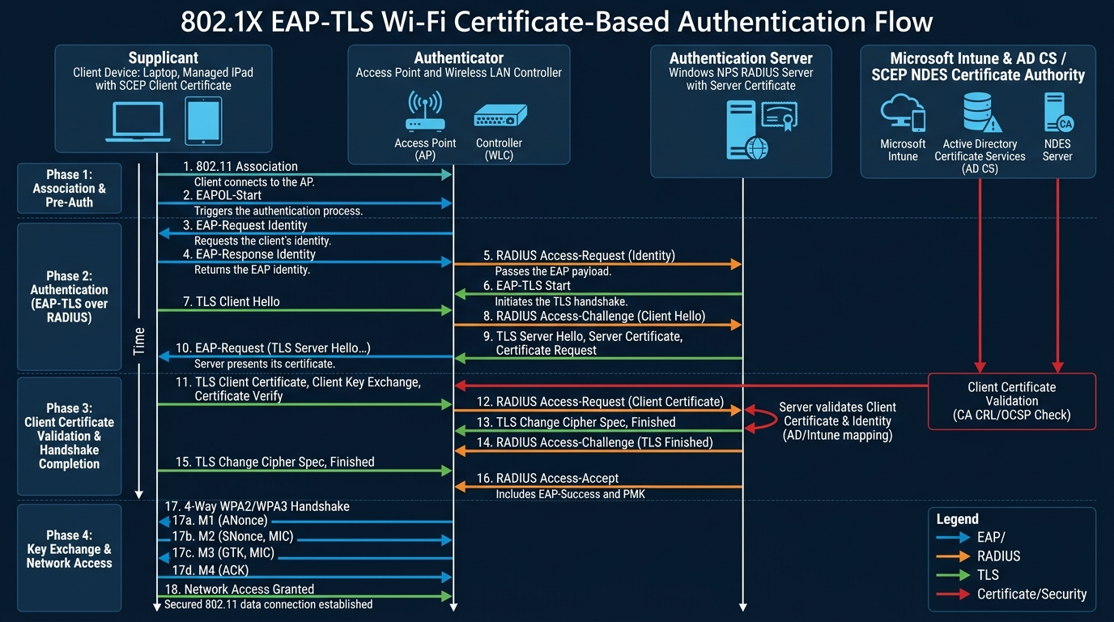
Figure 2: 802.1X Certificate-Based EAP-TLS Wi-Fi Protocol & Handshake Flow

5.1 Why EAP-TLS Replaces PSK and PEAP-MSCHAPv2
Method | Credentials Used | Vulnerabilities | Enterprise Suitability
WPA2-PSK | Shared passphrase | Passphrase leaks instantly; no per-user auditing; vulnerable to dictionary cracking. | Unsuitable for campus/enterprise networks.
WPA2-PEAP (MSCHAPv2) | AD Username & Password | Vulnerable to Evil Twin attacks; rogue AP steals MSCHAPv2 hashes for offline cracking. | High risk of credential harvesting.
802.1X EAP-TLS | X.509 Digital Certificates | Zero password transmission. Private keys locked in hardware TPM / Secure Enclave. | Gold standard. Immune to Evil Twin attacks and password phishing.

5.2 End-to-End EAP-TLS Deployment Architecture
- 1. Enterprise PKI (AD CS): Configures Certificate Templates with Client Authentication EKU (OID: 1.3.6.1.5.5.7.3.2) and validity period.
- 2. Microsoft Intune & SCEP / NDES: NDES acts as registration authority; Intune pushes Trusted Root CA and SCEP profiles to Windows laptops and supervised iPads silently.
- 3. Windows NPS (RADIUS Server): Configured with Server Authentication certificate (EKU: 1.3.6.1.5.5.7.3.1) and Network Policy enforcing EAP-TLS.
- 4. Dynamic VLAN Assignment: RADIUS returns standard attributes: Tunnel-Type = 13 (VLAN), Tunnel-Medium-Type = 6 (802), Tunnel-Private-Group-ID = <VLAN_ID> (Staff vs Student VLAN).

5.3 Troubleshooting EAP-TLS & Windows NPS
How to troubleshoot EAP-TLS failures in production:
Step 1: Check Windows Event Viewer -> Server Roles -> Network Policy Server:
- Event ID 6272: Access Granted (Success).
- Event ID 6273: Access Denied (Failure).
Step 2: Decode Common Event ID 6273 Reason Codes:
- Reason 16 (Credentials mismatch): Client cert issued by CA not trusted by NPS.
- Reason 22 (EAP type not processed): Cert template missing Client Auth EKU, or cert expired.
- Reason 23 (EAP error): CRL distribution point unreachable or OCSP check timed out.
- Reason 48 (Account disabled): AD user or computer object associated with cert is disabled.
Step 3: Client-Side Diagnostics:
- Windows: 'certmgr.msc' (Personal store), 'certlm.msc' (Trusted Root store),
'netsh wlan show wlanreport', 'netsh wlan show interfaces'
- Verify NTP Clock Synchronization: Skew > 5 mins causes hard TLS handshake failure.

6. Core Deep Dive 4: Enterprise Routing, Switching & Network Infrastructure

6.1 Layer 2 Switching & Spanning Tree Protocol (STP)
- 802.1Q VLAN Tagging: Inserts 4-byte tag into Ethernet header (TPID 0x8100, 12-bit VID for 4096 VLANs). Trunk ports carry tagged frames. Native VLAN carries untagged frames; always set Native VLAN to an unused ID (e.g. VLAN 999) to prevent double-tagging VLAN hopping.
- STP (802.1D) vs RSTP (802.1w): RSTP converges in sub-seconds using proposal/agreement handshakes. Bridge election: lowest Bridge ID (Priority + MAC) becomes Root Bridge.
- STP Security Features: PortFast (skips listening/learning on edge PC ports), BPDU Guard (err-disables edge ports if a rogue switch sends BPDUs), Root Guard (prevents rogue switches from becoming root), Loop Guard (prevents loops from unidirectional link failures).

6.2 Layer 2 Defense: DHCP Snooping, DAI, and IP Source Guard
- DHCP Snooping: Designates switch ports as Trusted (uplinks to DHCP server) or Untrusted (user access ports). Drops rogue DHCP offers on untrusted ports and builds the DHCP Snooping Binding Database.
- Dynamic ARP Inspection (DAI): Intercepts ARP packets on untrusted ports and validates IP-to-MAC bindings against the DHCP snooping table, completely preventing ARP poisoning and Man-in-the-Middle attacks.
- IP Source Guard: Dynamically filters traffic on untrusted ports to ensure packets match the assigned IP in the DHCP table, preventing IP address spoofing.
- Port Security: Restricts maximum MACs per port; 'mac-address sticky' saves learned MACs; violation modes include Protect, Restrict, and Shutdown (err-disable).

6.3 Layer 3 Routing & OSPF Deep Dive
Prefix | Subnet Mask | Total IPs | Usable Hosts | Block Size | Typical Use Case
/24 | 255.255.255.0 | 256 | 254 | 256 | Standard Department / User VLAN
/25 | 255.255.255.128 | 128 | 126 | 128 | Medium Subnet Segment
/26 | 255.255.255.192 | 64 | 62 | 64 | Small Office / Management Subnet
/27 | 255.255.255.224 | 32 | 30 | 32 | Server Farm / DMZ Segment
/28 | 255.255.255.240 | 16 | 14 | 16 | Appliance Cluster / Voice Gateway
/29 | 255.255.255.248 | 8 | 6 | 8 | Public WAN Block / Firewall HA Cluster
/30 | 255.255.255.252 | 4 | 2 | 4 | Point-to-Point Router Links
OSPF Neighbor Adjacency States (Must Memorize):
- Down -> Init -> 2-Way -> ExStart -> Exchange -> Loading -> Full: 2-Way establishes bidirectional communication and triggers DR/BDR election. In ExStart, master/slave relationship is negotiated. Full indicates link-state databases are 100% synchronized.
- Why OSPF Gets Stuck in ExStart: MTU Mismatch! If one router interface has MTU 1500 and the neighbor has MTU 1492, the Database Description (DBD) packet exceeds MTU and drops, locking the neighbor state in ExStart.

7. Core Deep Dive 5: Network Monitoring, Troubleshooting & Maintenance Operations

7.1 The OSI Model Systematic Troubleshooting Approach
- Layer 1 (Physical): Check link LEDs, fiber bend radius, SFP optical levels ('show interfaces transceiver detail'), CRC and input errors.
- Layer 2 (Data Link): Check duplex/speed mismatch, MAC address table, VLAN port assignment, and STP port blocking states.
- Layer 3 (Network): Verify IP/subnet mask, default gateway ping, DNS server ping, traceroute / mtr to locate dropped hops.
- Layer 4 (Transport): Verify TCP port reachability ('Test-NetConnection -Port 443', 'nc -zv'), firewall state tables, and ACL drops.
- Layer 7 (Application): Verify DNS resolution ('nslookup', 'dig'), SSL/TLS certificate validity, and proxy/gateway logs.

7.2 Wireshark Packet Analysis Cheatsheet
Wireshark Filter | What It Pinpoints
ip.addr == 10.10.10.50 && tcp.port == 443 | Isolates all HTTPS traffic to/from a specific host.
tcp.flags.syn == 1 && tcp.flags.ack == 0 | Filters pure TCP SYN connection initiation requests.
tcp.flags.reset == 1 | Isolates TCP RST packets (aborted connections by firewall or closed port).
tcp.analysis.retransmission | Identifies packet drops, congestion, or high latency on physical/WAN links.
tcp.analysis.zero_window | Indicates destination server receive buffer is full; cannot process data.
dns.flags.response == 0 | Shows outgoing DNS queries without filtering responses.
icmp.type == 3 | Shows ICMP Destination Unreachable messages (host, port, or fragmentation needed).

7.3 Network Maintenance & Firmware Upgrade Runbook
- Phase 1: Pre-Upgrade: Review release notes; verify SHA-256 hash of firmware image; obtain CAB change approval; backup configs via TFTP/SCP; document pre-upgrade routing/STP baseline.
- Phase 2: Execution: Upload to secondary partition; update boot variable; in HA clusters, upgrade passive unit first, failover, monitor live traffic, then upgrade active unit.
- Phase 3: Rollback Plan: If core routes fail to converge or interfaces remain down after 20 minutes, immediately revert boot variable pointer to previous partition and reboot.

8. High-Impact STAR Behavioral Interview Scenarios

Scenario 1: Deploying EAP-TLS Wi-Fi Across Multi-Campus ISB
- Situation: 1,100+ students and 350+ staff relied on shared WPA2-PSK passphrases, causing password leakage, no device accountability, and rogue connections.
- Task: Modernize network access control across laptops and supervised iPads using 802.1X certificate-based EAP-TLS.
- Action: Architected SCEP/NDES certificate distribution via Microsoft Intune; configured Windows NPS RADIUS policies; set up dynamic VLAN assignment on WLC/APs; and managed Barracuda NGFW content filtering.
- Result: Completely eliminated shared passphrases and evil-twin attack vectors; reduced Wi-Fi helpdesk tickets by 40%; provided full device auditability.

Scenario 2: Troubleshooting Sudden Network Outage / High Firewall Drop
- Situation: Users across multiple departments lost internet access during peak hours, while internal printing still worked.
- Task: Diagnose root cause, restore WAN connectivity, and prevent recurrence.
- Action: Ruled out L1/L2 since local LAN worked; checked Barracuda NGFW CPU and WAN saturation; filtered Live Log and found a rogue workstation flooding UDP packets from a malware infection; shut down the switch port and cleared firewall state tables.
- Result: Restored WAN connectivity within 12 minutes; quarantined infected endpoint; implemented egress UDP rate-limiting and updated IPS signatures.

Scenario 3: Leading ISO 27001 Implementation & Audit Readiness (EVYD Technology)
- Situation: EVYD Technology required ISO 27001 certification to validate its health data platform security.
- Task: Serve as ISMS Management Representative leading technical security controls across infrastructure.
- Action: Implemented firewall/WAF controls, Sentinel SIEM logging, vulnerability scans with Nessus, and standardized network documentation.
- Result: Achieved ISO 27001 certification with zero major non-conformities; established sustainable SOPs.

9. Strategic Questions to Ask ESCA Interviewers
- 1. Infrastructure Ecosystem: "What is ESCA's primary network hardware and firewall ecosystem across client projects—is it predominantly Cisco, Fortinet, Aruba, or multi-vendor? How are you handling SD-WAN?"
- 2. Upcoming Projects: "What are the most critical network infrastructure projects in ESCA's pipeline for the coming 6 to 12 months—such as campus overhauls, data center migrations, or wireless upgrades?"
- 3. Network Security Strategy: "How is ESCA currently approaching network perimeter defense and access control—are clients transitioning toward Zero Trust segmentation, 802.1X certificate authentication, or identity-aware firewalls?"
- 4. Professional Development: "ESCA has a strong engineering footprint in Brunei. How does the company support engineering certifications and continuous development for network engineers on the team?"

